眼底山川——饒宗頤教授寰宇藝踪
Embracing Landscapes: The Artistic Journey of Professor Jao Tsung-i

 | 圖片 Images | 説明 | Captions
1 | 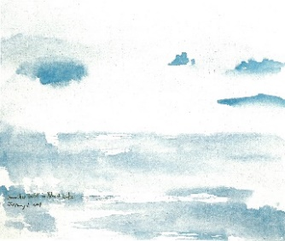 | 《馬蹄灣》  饒宗頤（1917–2018）  2009年  設色丙烯布本  高50 x 闊60厘米  圖片來源：饒宗頤基金 | Horseshoe Inlet, Australia  Jao Tsung-i (1917–2018)  2009  Acrylic on canvas  H.50 x W.60 cm  Image courtesy of the Jao Tsung I Foundation
2 | 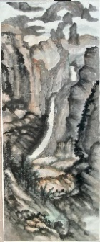 | 《青山山色》  饒宗頤（1917–2018）  1980年代  設色水墨紙本  高367 x 闊144厘米  圖片來源：饒宗頤基金 | Castle Peak, Hong Kong  Jao Tsung-i (1917–2018)  1980s  Ink and colour on paper  H.367 x W.144 cm  Image courtesy of the Jao Tsung I Foundation
3 | 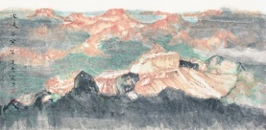 | 《大峽谷寫生》  饒宗頤（1917–2018）  1990年  設色水墨紙本  高68 x 闊136厘米  圖片來源：饒宗頤基金 | Sketch of the Grand Canyon  Jao Tsung-i (1917–2018)  1990  Ink and colour on paper  H.68 x W.136 cm  Image courtesy of the Jao Tsung I Foundation
4 | 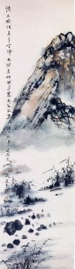 | 《榆城雪霽》  饒宗頤（1917–2018）  1988年  設色水墨紙本立軸  高138 x 闊34厘米  圖片來源：饒宗頤學術館 | Snow in Elm City  Jao Tsung-i (1917–2018)  1988  Hanging scroll, Ink and colour on paper  H.138 x W.34 cm  Image courtesy of the Jao Tsung-I Petite Ecole

